**DISCIPLINE**

1)--Discipline Event with the most number of students

**SQL**

Select a.DisciplineEventCode,a.DisciplineEventDesc, COUNT(distinct b.StudentID) AS Student_Count

from dimDisciplineEventCode a

JOIN

factDiscipline b

ON a.DisciplineEventCodeID = b.DisciplineEventCodeID

JOIN

dimStudent c

ON b.StudentID = c.StudentID

GROUP BY a.DisciplineEventCode,a.DisciplineEventDesc

**OUTPUT**

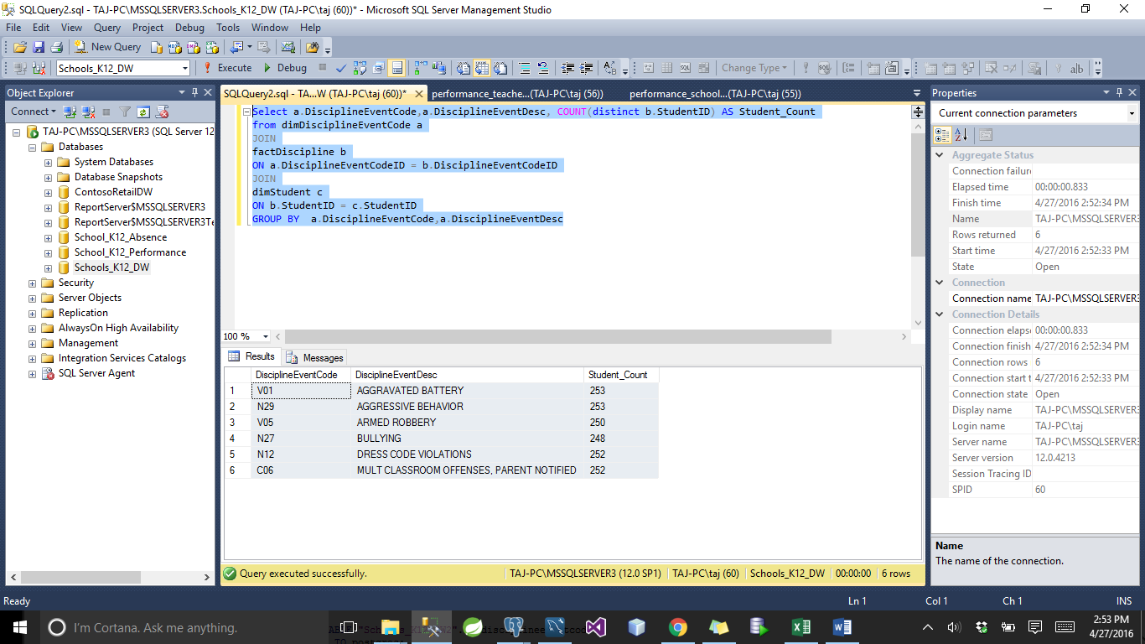

**POSTGRES**

Select a.disciplineeventcode,a.disciplineeventcode, COUNT(distinct b.studentid) AS studentcount

from "Schools_K12_DW2".dimdisciplineeventcode AS a

JOIN

"Schools_K12_DW2".factdiscipline AS b

ON a.disciplineeventcodeid = b.disciplineeventcodeid

JOIN

"Schools_K12_DW2".dimstudent AS c

ON b.studentid = c.studentid

GROUP BY a.disciplineeventcode,a.disciplineeventdesc

**OUTPUT**

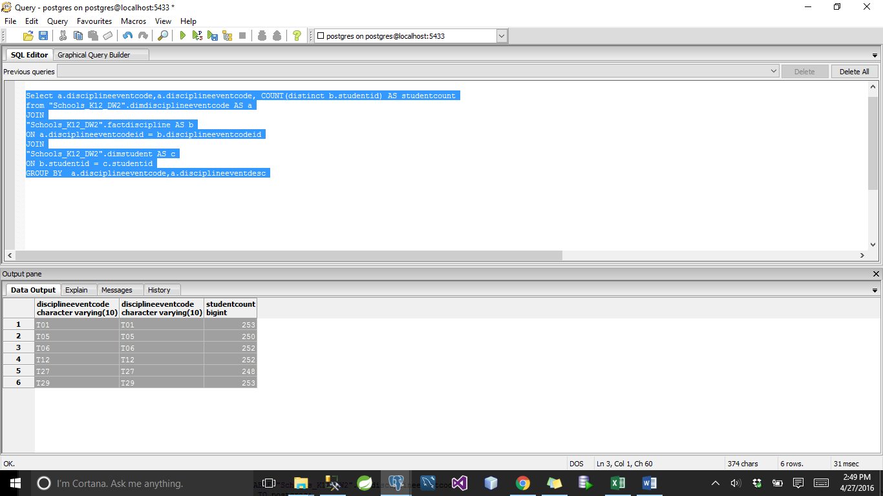

**2)** **Did men have more discipline complains recorded for each didciplineEvent ?**

Select a.DisciplineEventCode,a.DisciplineEventDesc,c.Gender, COUNT(distinct b.StudentID) AS Student_Count

from dimDisciplineEventCode a

JOIN

factDiscipline b

ON a.DisciplineEventCodeID = b.DisciplineEventCodeID

JOIN

dimStudent c

ON b.StudentID = c.StudentID

GROUP BY a.DisciplineEventCode,a.DisciplineEventDesc,c.Gender

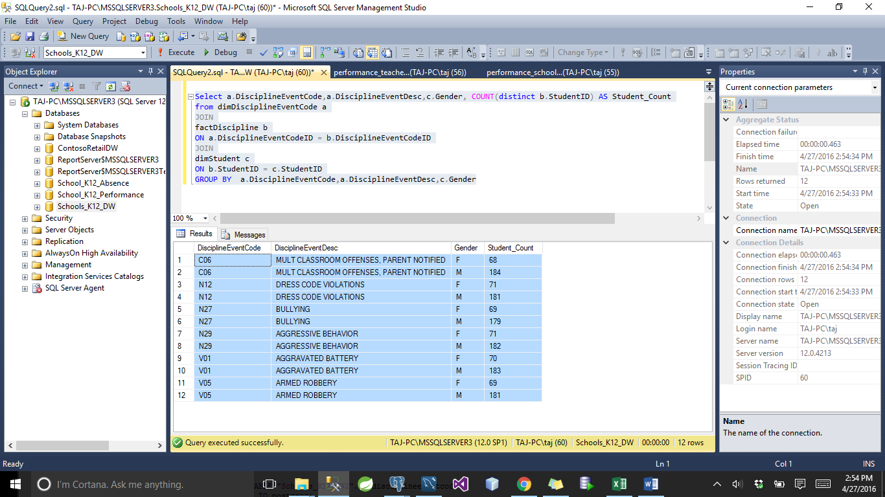

**Postgres**

2) select a.disciplineeventcode,a.disciplineeventdesc,c.gender, COUNT(distinct b.studentID) AS studentcount

from "Schools_K12_DW2".dimdisciplineeventcode AS a

JOIN

"Schools_K12_DW2".factdiscipline AS b

ON a.disciplineeventcodeid = b.disciplineeventcodeid

JOIN

"Schools_K12_DW2".dimstudent AS c

ON b.studentid = c.studentid

GROUP BY a.disciplineeventcode,a.disciplineeventdesc,c.gender

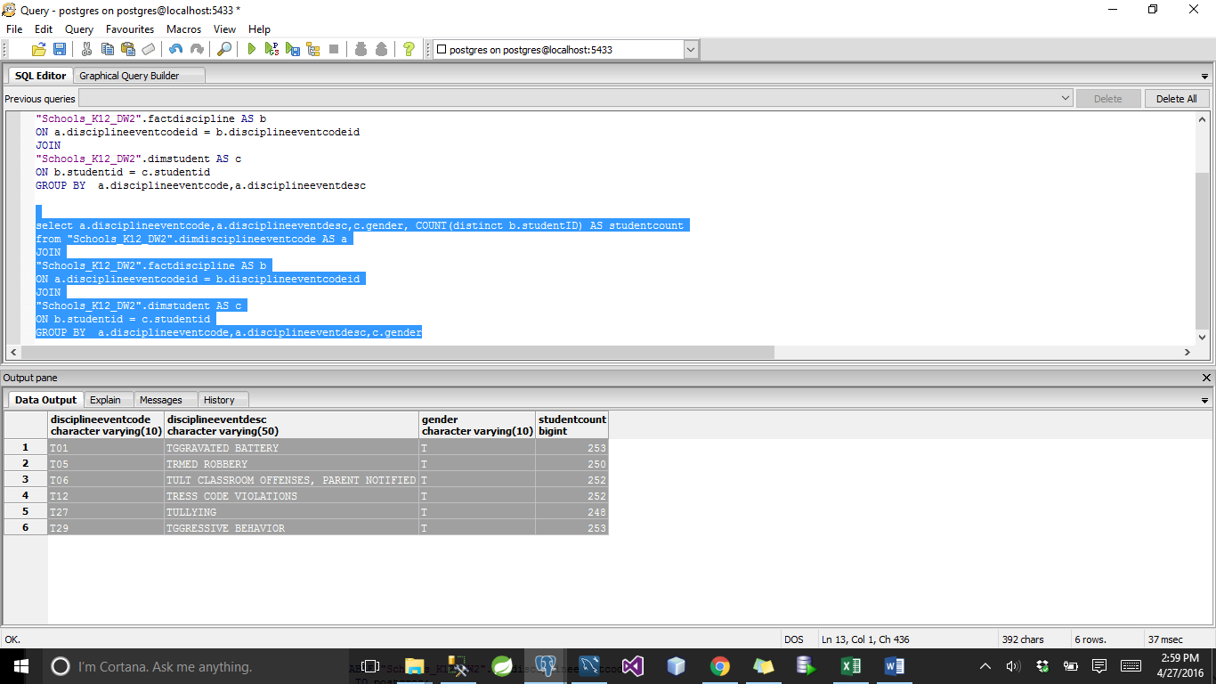

**3) top 5 Student with the highest number of discipline violations**

**SQL**

Select top 5 c.StudentID, count(a.DisciplineEventCode) AS Number_Of_Violations

from dimDisciplineEventCode a

JOIN

factDiscipline b

ON a.DisciplineEventCodeID = b.DisciplineEventCodeID

JOIN

dimStudent c

ON b.StudentID = c.StudentID

GROUP BY c.StudentID

ORDER BY count(a.DisciplineEventCode) desc;

**OUTPUT**

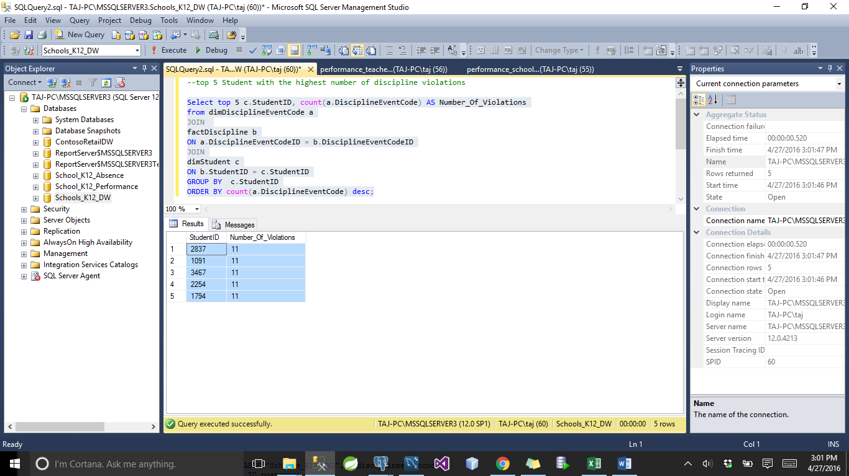

**PostGres**

Select c.studentid, count(a.disciplineeventcode) AS numberofviolations

from "Schools_K12_DW2".dimdisciplineeventcode AS a

JOIN

"Schools_K12_DW2".factDiscipline AS b

ON a.disciplineeventcodeid = b.disciplineeventcodeid

JOIN

"Schools_K12_DW2".dimstudent AS c

ON b.studentid = c.studentid

GROUP BY c.studentid

ORDER BY count(a.disciplineeventcode) desc

limit 5;

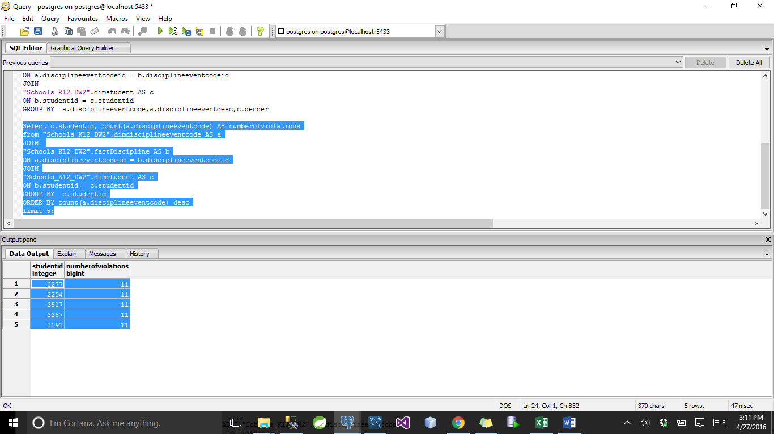

**4)** --top staff who have taken action against discipline violations

select top 1 StaffID, StaffFirstName,StaffLastName, COUNT(b.DisciplineActionCodeID) AS number_of_actions

from dimDisciplineActionCode a

JOIN

factDiscipline b

ON a.DisciplineActionCodeID = b.DisciplineActionCodeID

JOIN

dimStaff c

ON b.ActionStaffID = c.StaffID

GROUP BY StaffID, StaffFirstName,StaffLastName

**OUTPUT**

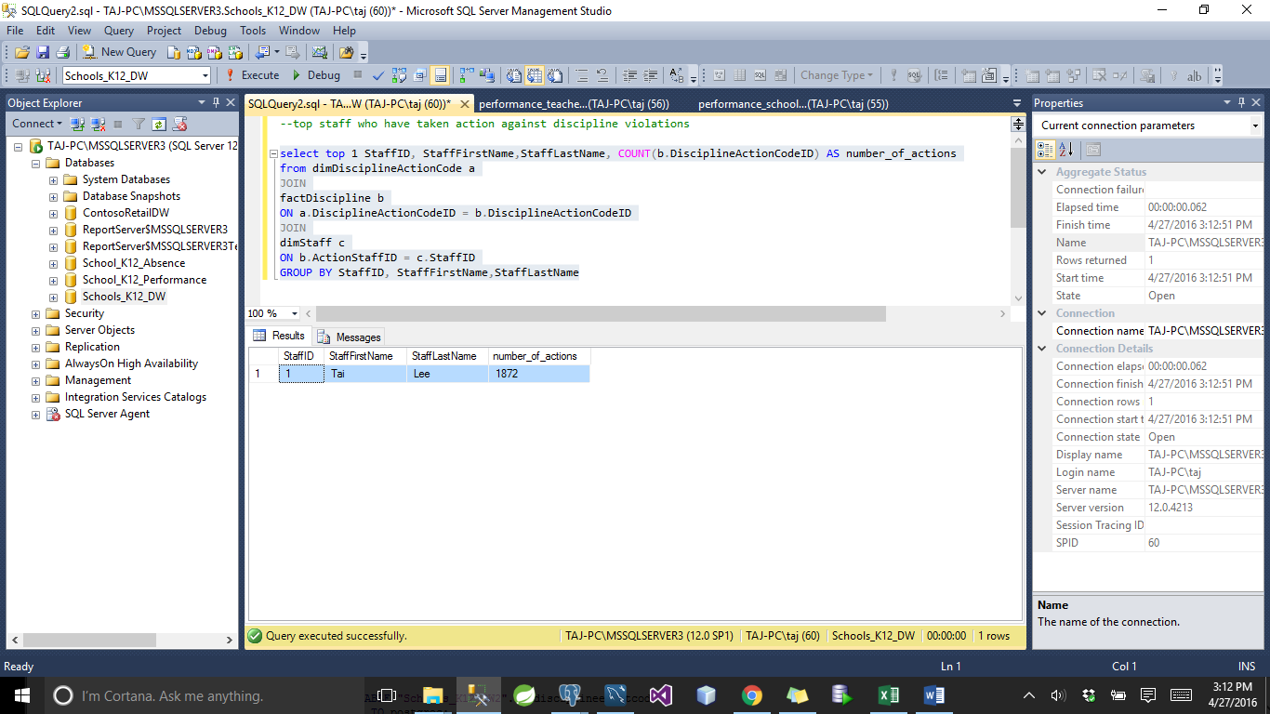

**PostGres**

select staffid, stafffirstName,stafflastname, COUNT(b.disciplineactioncodeid) AS numberofactions

from "Schools_K12_DW2".dimdisciplineactioncode AS a

JOIN

"Schools_K12_DW2".factdiscipline AS b

ON a.disciplineactioncodeid = b.disciplineactioncodeid

JOIN

"Schools_K12_DW2".dimstaff AS c

ON b.actionstaffid = c.staffid

GROUP BY staffid, stafffirstname,stafflastname

limit 1;

**OUTPUT**

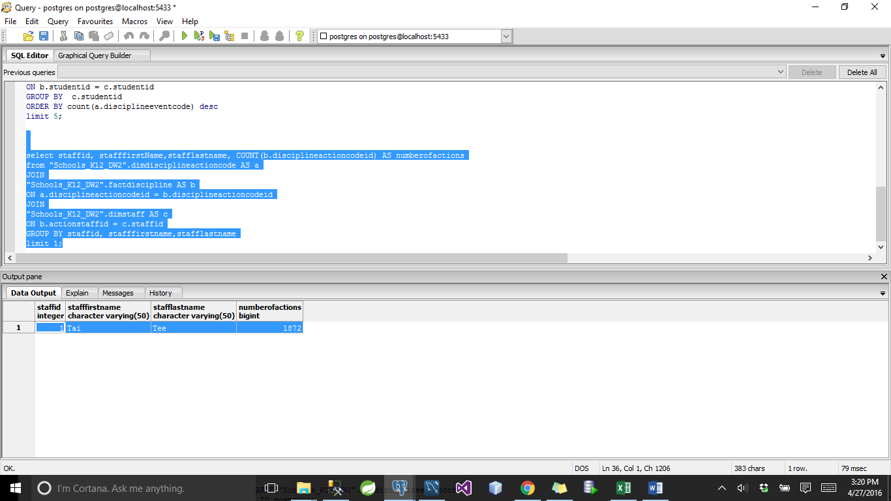

**5)**

--How did different ethnic groups varying wrt DRESS CODE VIOLATIONS

Select a.DisciplineEventCode,a.DisciplineEventDesc,c.Ethnicity, COUNT(distinct b.StudentID) AS Student_Count

from

(Select a.DisciplineEventCode, DisciplineEventCodeID,a.DisciplineEventDesc

from dimDisciplineEventCode a

where a.DisciplineEventCode='N12'

)a

JOIN

factDiscipline b

ON a.DisciplineEventCodeID = b.DisciplineEventCodeID

JOIN

dimStudent c

ON b.StudentID = c.StudentID

GROUP BY a.DisciplineEventCode,a.DisciplineEventDesc,c.Ethnicity

ORDER BY COUNT(distinct b.StudentID) desc

**OUTPUT**

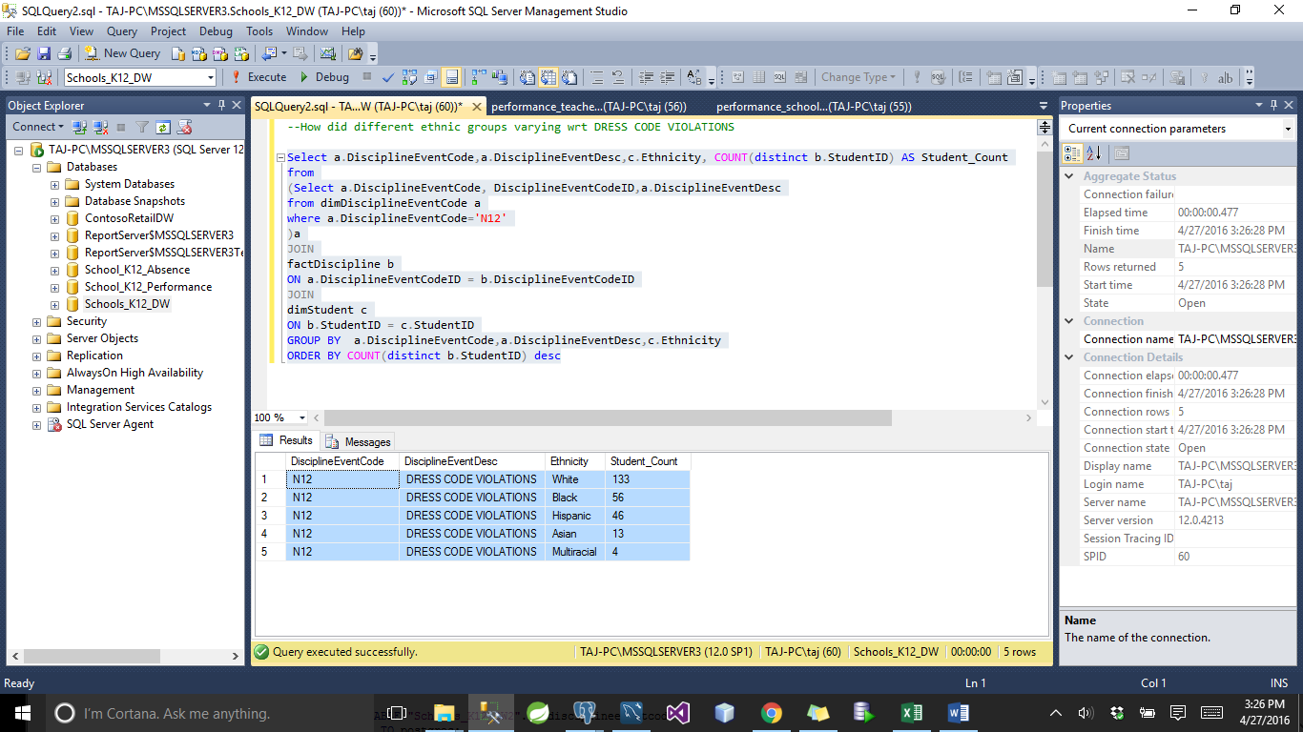

**PostGres**

select a.disciplineeventcode,a.disciplineeventdesc,c.ethnicity, COUNT(distinct b.studentid) AS studentcount

from

(Select a.disciplineeventcode, disciplineeventcodeid,a.disciplineeventdesc

from "Schools_K12_DW2".dimdisciplineeventcode AS a

where a.disciplineeventcode='N12'

) AS a

JOIN

"Schools_K12_DW2".factdiscipline b

ON a.disciplineeventcodeid = b.disciplineeventcodeid

JOIN

"Schools_K12_DW2".dimstudent c

ON b.studentid = c.studentid

GROUP BY a.disciplineeventcode,a.disciplineeventdesc,c.ethnicity

ORDER BY COUNT(distinct b.studentid) desc

6)

-- How is grade distribute amongst the students who violate dresscode

Select a.DisciplineEventCode,a.DisciplineEventDesc,c.Grade, COUNT(distinct b.StudentID) AS Student_Count

from

(Select a.DisciplineEventCode, DisciplineEventCodeID,a.DisciplineEventDesc

from dimDisciplineEventCode a

where a.DisciplineEventCode='N12'

)a

JOIN

factDiscipline b

ON a.DisciplineEventCodeID = b.DisciplineEventCodeID

JOIN

dimStudent c

ON b.StudentID = c.StudentID

GROUP BY a.DisciplineEventCode,a.DisciplineEventDesc,c.Grade

ORDER BY COUNT(distinct b.StudentID) desc;

**OUTPUT**

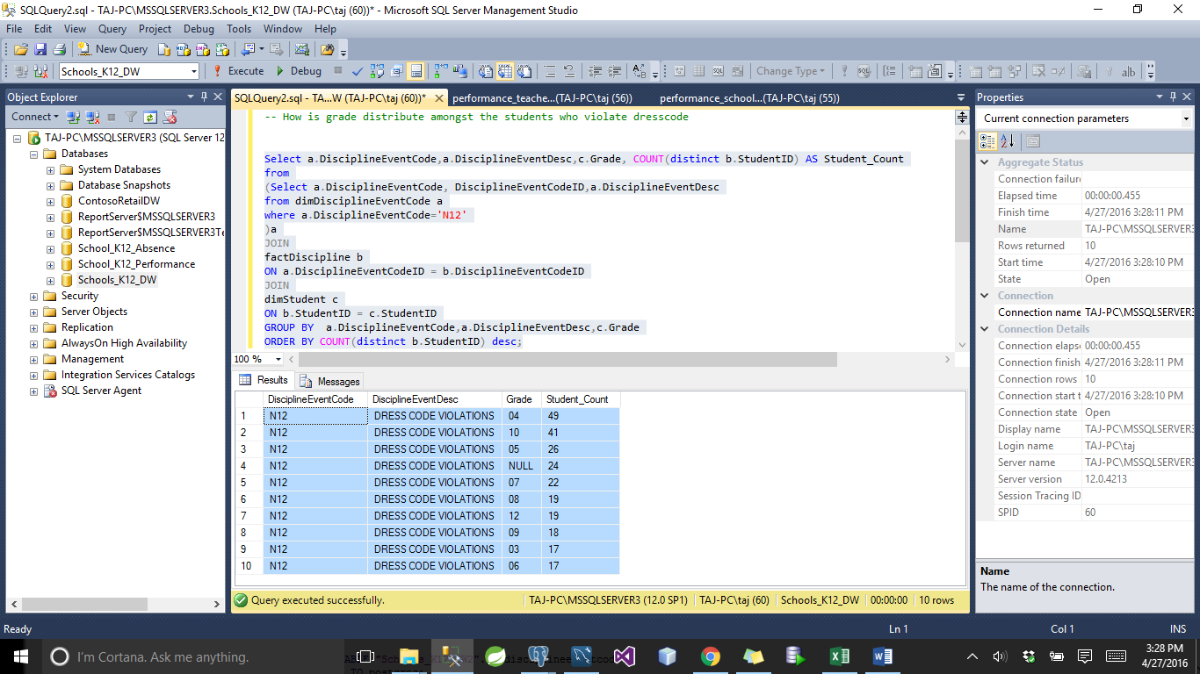

**PostGres**

Select a.disciplineeventcode,a.disciplineeventdesc,c.grade, COUNT(distinct b.studentid) AS studentcount

from

(Select a.disciplineeventcode, disciplineeventcodeid,a.disciplineeventdesc

from "Schools_K12_DW2".dimdisciplineeventcode AS a

where a.disciplineeventcode='N12'

)AS a

JOIN

"Schools_K12_DW2".factdiscipline AS b

ON a.disciplineeventcodeid = b.disciplineeventcodeid

JOIN

"Schools_K12_DW2".dimstudent c

ON b.studentid = c.studentid

GROUP BY a.disciplineeventcode,a.disciplineeventdesc,c.grade

ORDER BY COUNT(distinct b.studentid) desc;

7)

--Which city has the highest number of discipline violating students

Select a.DisciplineEventCode,a.DisciplineEventDesc,c.State, COUNT(distinct b.StudentID) AS Student_Count

from dimDisciplineEventCode a

JOIN

factDiscipline b

ON a.DisciplineEventCodeID = b.DisciplineEventCodeID

JOIN

dimStudent c

ON b.StudentID = c.StudentID

GROUP BY a.DisciplineEventCode,a.DisciplineEventDesc,c.State

ORDER BY COUNT(distinct b.StudentID) desc;

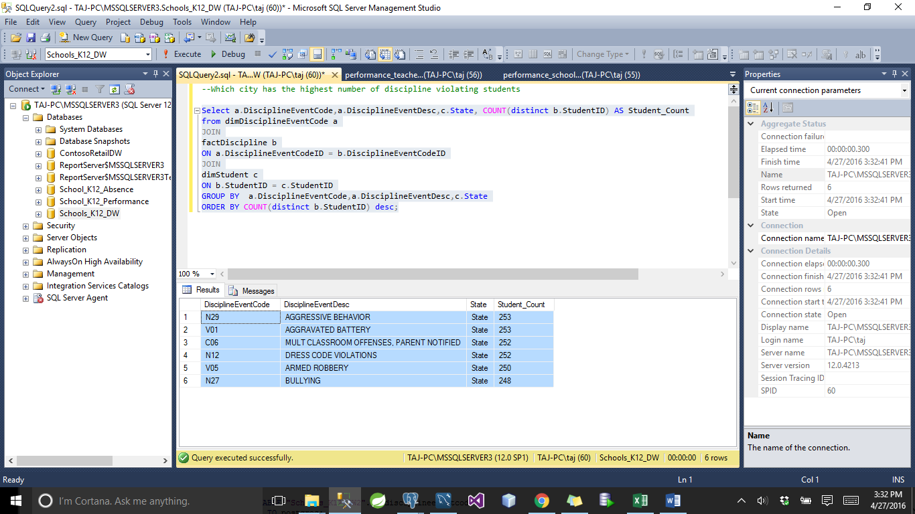

**PostGres**

Select a.disciplineeventcode,a.disciplineeventdesc,c.state, COUNT(distinct b.studentid) AS studentcount

from "Schools_K12_DW2".dimdisciplineeventcode AS a

JOIN

"Schools_K12_DW2".factdiscipline AS b

ON a.disciplineeventcodeid = b.disciplineeventcodeid

JOIN

"Schools_K12_DW2".dimstudent c

ON b.studentid = c.studentid

GROUP BY a.disciplineeventcode,a.disciplineeventdesc,c.state

ORDER BY COUNT(distinct b.studentid) desc;

**OUTPUT**

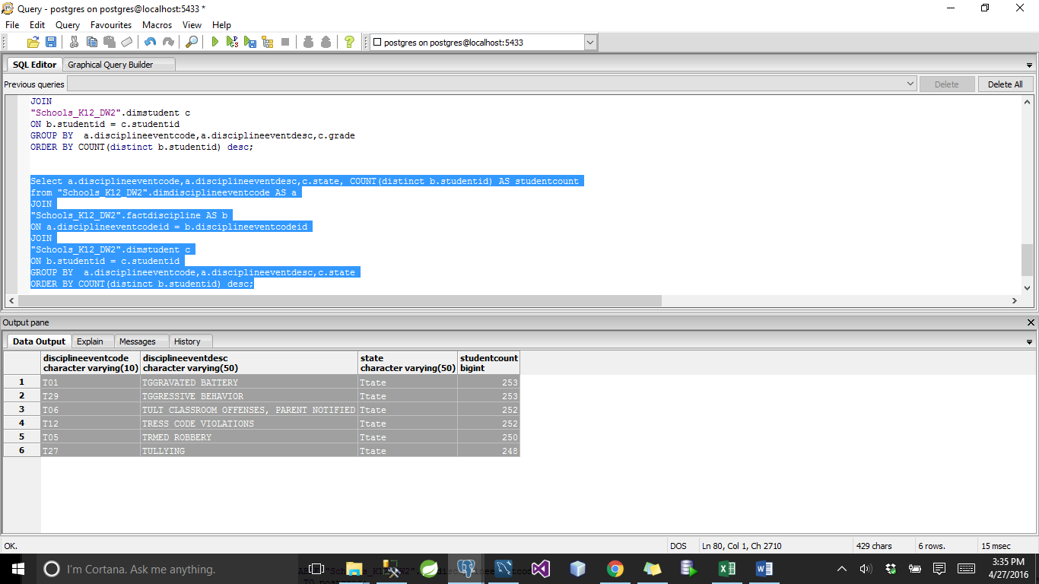

**ABSENCE**

**1)**

--Analysis

--1. When is the absence rate high?

select c.StaffID, c.StaffFirstName,c.StaffLastName,count(AbsenceCode) as no_handled_absence

from dimAbsenceCode a

JOIN

factAbsence b

ON a.AbsenceCodeID = b.AbsenceCodeID

JOIN

dimStaff c

ON b.StaffID = c.StaffID

GROUP BY c.StaffID,c.StaffFirstName,c.StaffLastName

order by count(AbsenceCode) desc

**OUTPUT**

